Hanging Instructions!
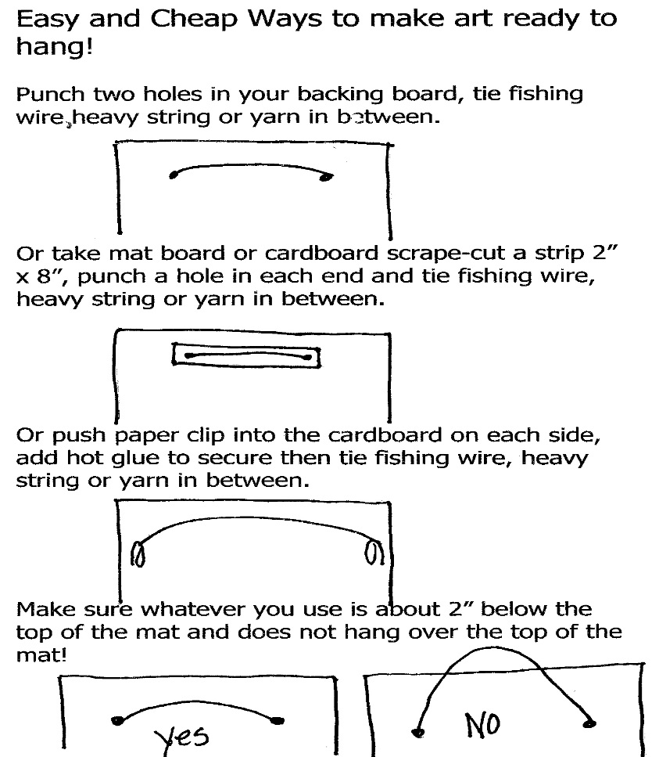
Please make sure:
- Your hanging device is placed directly in the center of your backing
- No yarn or any material that will stretch over time (fishing line works well!)
- All artwork must have a stiff backing in addition to a quality matt.
- If you use a pre-made matt, please take extra care to ensure the matt stays clean and presentable
- Attach labels with rubber cement so they can easily be replace if necessary
Labels should be Arial 12 pt. font and include:
Student Name
Title
Media
School Name
Region
Grade Level

